1. Run local k8s cluster: kind/minikube/…

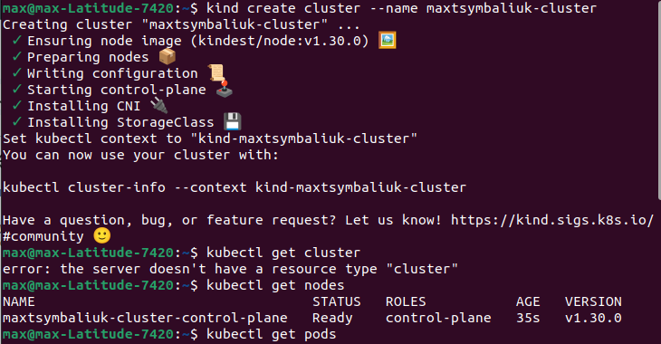

1. Install Vault using helm

Add repo



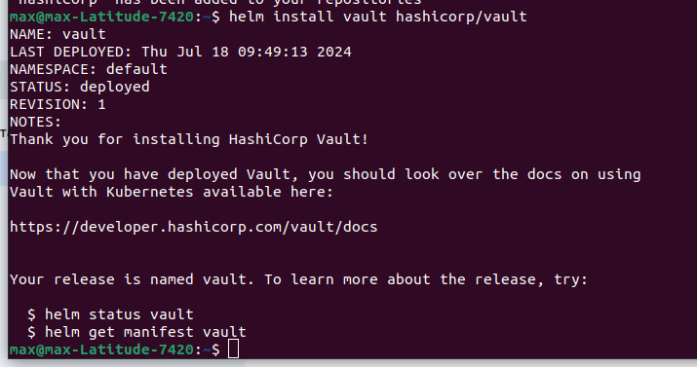

1. Create secret in vault and add other configuration



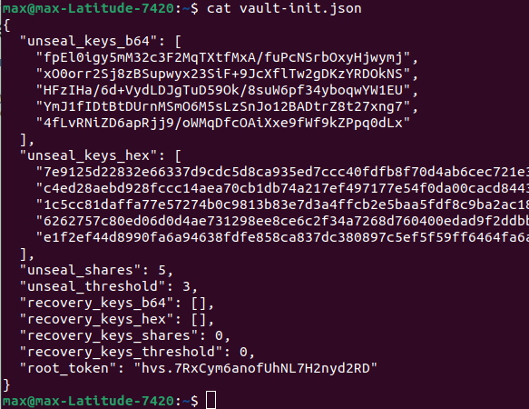

Unseal Vault 3 times

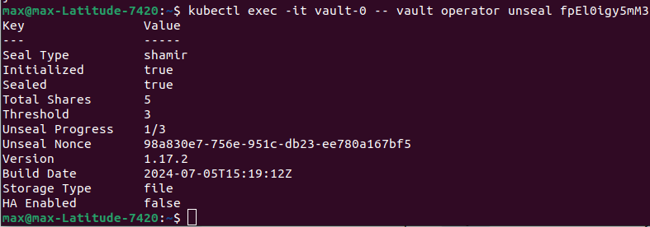

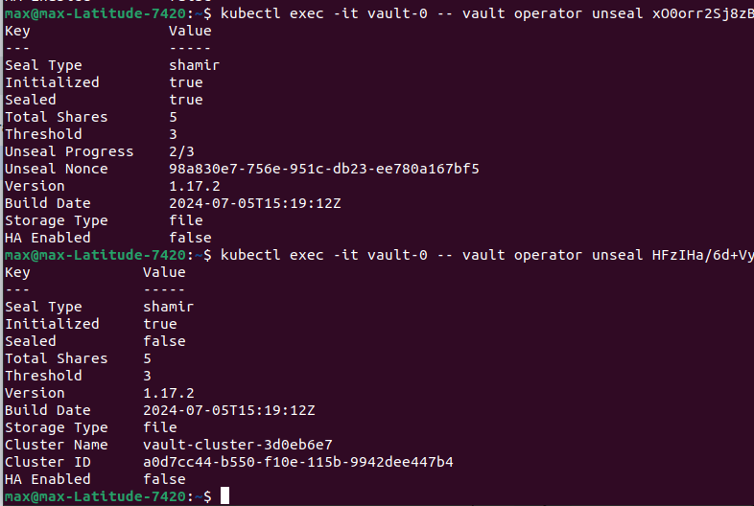

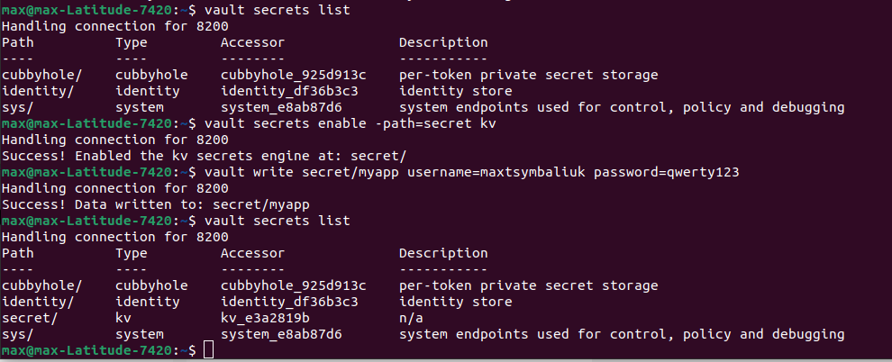

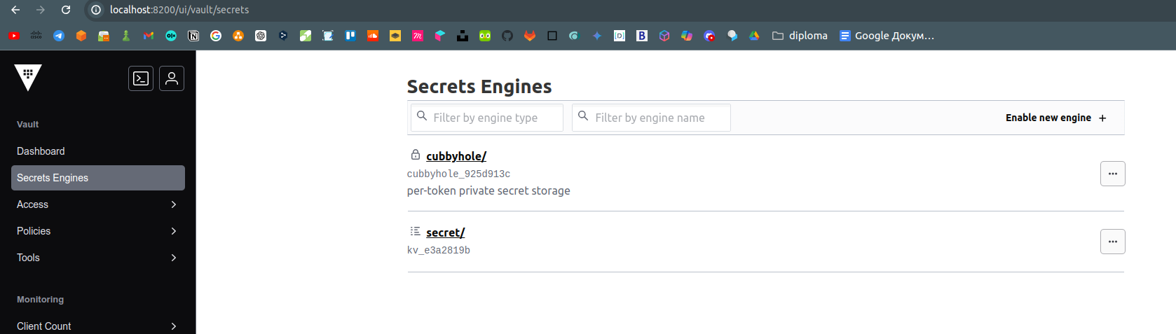

1. Setup test postgres as on lesson



1. Confirm that secret was added to the pod

